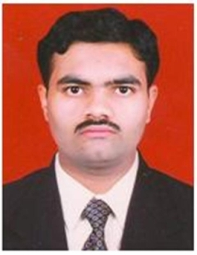

Name: Prof. Pradip Shankarao Gunavant
Fathers Name: Shankarao Shrirang Gunavant
Department: Mechanical Engineering
Date of Joining: 01 July 2013
Designation: Assistant Professor
Phone No. : 9975575667 Email ID: psgunvant.mech@dacoe.ac.in
Permanent Address: At Post - Shivajinagar
Taluka: Kadegaon Dist.: Sangli State: Maharashtra
Marital Status: -Married Blood Group: O^{+Ve}
Date of Birth: 13/05/1984 Place of Birth: Shivajinagar
- Educational Qualifications:
Degree | University/Board | Percentage | Class Obtained | Year of Passing
ME  (Mech - Heat Power Engg.) | Shivaji University, Kolhapur | 67.83 % | First Class | 2013
BE (Mechanical) | Shivaji University, Kolhapur | 71.09 % | First Class with Distinction | 2007
DME | MSBTE, Mumbai | 71.53 % | First Class | 2004

- Experience (Years):
Teaching | 9.5 Years | Industrial | 2.5 Years | Others | - | Total | 12 Years

- Paper/ Books Published:
Details | National | International | State | SCI/  Scopus Indexed | UGC  Approved
Journals | - | 2 | - | 2 | 1
Conferences | 5 | 4 | - | - | -

- FDP/STTP/Seminars/Workshop organized/Attended:
Details | Organized | Attended
FDP/STTP | 1 | 10
Seminar | 1 | 1
Workshop | 1 | 4
Technical Event | 4 | -
Others | - | -

