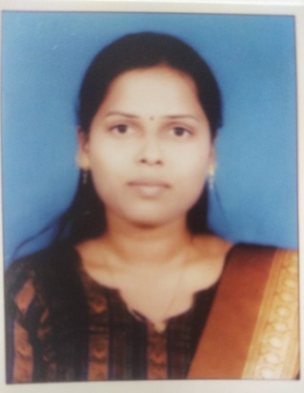

Name: Reva Vikram Jagtap
Fathers/Husbands Name: Vikram
Department: Mechanical Engineering
Date of Joining: 01/11/2023 Designation: Assistant Professor
Phone No. 7796705055 Email ID: rvjagtap.mech@dacoe.ac.in
Permanent Address: House No-24,A/P-Kodoli , Tal-Karad Dist-Satara
Taluka: _Karad Dist.: Satara_ State: Maharashtra
Local Address: House No-24,A/P-Kodoli, Tal: Patan Dist: Satara
Taluka: _Karad Dist.: Satara_ State: Maharashtra
Marital Status: -Married_Blood Group: B-ve
Date of Birth: 4th June 1994 Place of Birth: Kasar Shirambe Tal Karad
- Educational Qualification:
Degree | University/Board | Percentage | Class Obtained | Year of Passing
PhD
ME / M. Tech | Shivaji University,Kolhapur | 72.35 | First Class | Nov 2020
BE / B. Tech | Shivaji University,Kolhapur | 73.50 | First Class With Dist. | June 2015
12th Science | Maharashtra State Board | 70.33 | First Class | June 2011
- Experience (Years):
Teaching | 4.7 | Industrial | - | Others | - | Total | 4.7 Years

- Paper/ Books Published:
Details | National | International | State | SCI/  ScopusIndexed | UGC  Approved
Journals |  | 2
Conferences

- FDP/STTP/Seminars/Workshop organized/Attended:
Details | Organised | Attended
FDP/STTP |  | 02
Seminar
Workshop
Technical Event
Others

