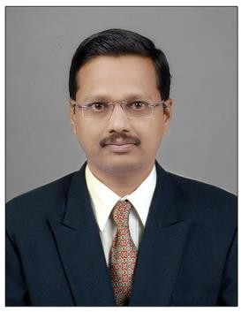
Name: Dr.Vahid Mansur Jamadar
Fathers/Husbands Name: Mansur Babasaheb Jamadar
Department: Mechanical
Date of Joining: 09/07/2013 Designation: Assistant Professor
Phone No.9960044175 Email ID: vmjamadar.mech@dacoe.ac.in
Permanent Address: Aman Manzil, Govindgirinagar, Near Cannol Road A/P: Kadegaon
Taluka: Kadegaon Dist.: Sangli State: Maharashtra
Local Address: Aman Manzil, Govindgirinagar, Near Cannol Road A/P: Kadegaon
Taluka: Kadegaon Dist.: Sangli State: Maharashtra
Marital Status: Married Blood Group: B+
Date of Birth: 31/07/1981 Place of Birth: Bhilawadi
Educational Qualification:
Degree | University | Percentage | Class Obtained | Year of Passing
PhD | Maharishi University,Lucknow | - | - | 2021
ME / M. Tech | Shivaji University | 68.83% | Ist Class | 2013
BE / B. Tech | Shivaji University | 67.76% | I ^{st} Class with Distinction | 2006

- Experience (Years):
Teaching | 13 | Industrial | 1.8 | Others | - | Total | 14.8

- Paper/ Books Published:
Details | National | International | SCI/  Scopus Indexed | UGC  Approved
Journals | 01 | 05 | 02 | 02
Conferences | 01 | 02 | 02 | -

- FDP/STTP/Seminars/Workshop organized/Attended:
Details | Organised | Attended
FDP/STTP | 01 | 20
Seminar | 01 | 05
Workshop | 02 | 10
Technical Event | - | 02

