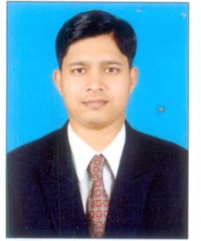

Name: Mr.Ranjit Raghunath Chavan
Father Name: Mr.Raghunath Pandurang Chavan
Department: Mechanical Engineering
Date of Joining: 01/09/2021 Designation: Assistant Professor
Phone No.: 8329890240 Email ID: rrchavan.mech@dacoe.ac.in
Permanent Address: At Post Koparde Haveli, Near Sahyadri Rice Mill
Taluka: Karad Dist.: Satara State: Maharashtra
Local Address: At Post Koparde Haveli,
Taluka: Karad Dist.: Satara State: Maharashtra
Marital Status: - Unmarried Blood Group: B^{+ve}
Date of Birth: 12-05-1989 Place of Birth: Karad
- Educational Qualification:
Degree | University/Board | Percentage | Class Obtained | Year of Passing
PhD
M. Tech | Shivaji University | 8.93 CPI | Distinction | 2014-15
BE / B. Tech | Shivaji University | 72.06 | Distinction | 2011-12
Diploma | MSBTE | 80.25 | Distinction | 2008-09

- Experience (Years):
Teaching | 4.8 Year | Industrial | - | Others | - | Total | 4.8 Year

- Paper/ Books Published:
Details | National | International | State | SCI/  Scopus Indexed | UGC  Approved
Journals | 01 | 02 | MH | Yes | Yes
Conferences | 01 |  | MH | NO | Yes

- FDP/STTP/Seminars/Workshop organized/Attended:
Details | Organized | Attended
FDP/STTP |  | 03
Seminar
Workshop | 01 | 01
Technical Event
Others

