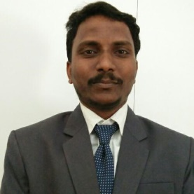

Name: Prashant Patangrao Bhise
Fathers/Husbands Name: Patangrao
Department: Mechanical Engineering
Date of Joining: 01/08/2022 Designation: Assistant Professor
Phone No. 9766286956 Email ID: ppbhise.mech@dacoe.ac.in
Permanent Address: A/P Mhavashi Peth , Tal Patan Dist Satara
Taluka: _PATAN Dist.: Satara_ State: Maharashtra
Local Address: A/P Mhavashi Peth , Tal Patan Dist Satara
Taluka: _PATAN Dist.: Satara_ State: Maharashtra
Marital Status: -Married_Blood Group: B+ve
Date of Birth: 2nd March 1986 Place of Birth: Yevati Tal Karad
- Educational Qualification:
Degree | University/Board | Percentage | Class Obtained | Year of Passing
PhD
ME / M. Tech | Dr BAMU Aurangabad | 6.78 CGPA | First Class | 2018
BE / B. Tech | Dr BAMU Aurangabad | 67.66% | First Class With Dist. | 2010
DME | MSBTE | 70.92% | First Class | 2007

- Experience (Years):
Teaching | 7.5 | Industrial | 6 Months | Others |  | Total | 8 Years

- Paper/ Books Published:
Details | National | International | State | SCI/  ScopusIndexed | UGC  Approved
Journals |  | 1 |  |  | 1
Conferences | 1 |  |  |  | 0

- FDP/STTP/Seminars/Workshop organized/Attended:
Details | Organised | Attended
FDP/STTP |  | 02
Seminar
Workshop |  | 01
Technical Event
Others |  | 01

