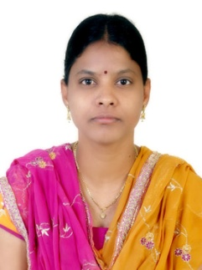

Name: Ms. Sumalatha Dhanraj Bandari
Fathers/Husbands Name: Dr. Laxman Kumarwad
Department: Computer Science and Engineering
Date of Joining: 15/06/2012 Designation: Assistant Professor
Phone No.: 9960022681 Email ID: sdbandari.cse@dacoe.ac.in
Permanent Address: EF-1, Silver Woods Sunrise Society, Banawadi Phata, Vidya Nagar
Taluka: Karad Dist.: Satara State: Maharashtra
Local Address: EF-1, Silver Woods Sunrise Society, Banawadi Phata, Vidya Nagar
Taluka: Karad Dist.: Satara State: Maharashtra
Marital Status: Married Blood Group: AB+
Date of Birth: 20/05/1982 Place of Birth: Nizamabad, State: Telangana
- Educational Qualification:
Degree | University/Board | Percentage | Class Obtained | Year of Passing
PhD | JNTUH (Pursuing)
ME / M. Tech | JNTUH | 74.48 | Distinction | 2010
BE / B. Tech | JNTUH | 69.66 | First Class | 2005
others

- Experience (Years):
Teaching | 16.3 Years | Industrial | - | Others | - | Total | 16.3 Years

- Paper/ Books Published:
Details | National | International | State | SCI/  ScopusIndexed | UGC  Approved
Journals |  | 9 |  | 1
Conferences | 4 | 4

- FDP/STTP/Seminars/Workshop organized/Attended:
Details | Organised | Attended
FDP/STTP | 2 | 24
Seminar |  | 1
Workshop | 2 | 14
Technical Event
Others

