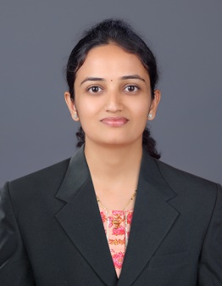
Name: Dr. Pranali Sheth
Husbands Name: Mehul
Department: Computer Science & Engineering
Date of Joining: 27/06/2022 Designation: Associate Professor
Phone No. 8605715823 Email ID: pmsheth.cse@dacoe.ac.in
Permanent Address: 36, Market Yard, Shaniwar Peth, Karad. 415110.
Taluka: Karad Dist.: Satara State: Maharashtra
Local Address: 36, Market Yard, Shaniwar Peth, Karad. 415110.
Taluka: Karad Dist.: Satara State: Maharashtra
Marital Status: - Married Blood Group: B Rh (Negative)
Date of Birth: 06 October 1989 Place of Birth: Sangli
- Educational Qualification:
Degree | University/Board | Percentage | Class Obtained | Year of Passing
PhD | Savitribai Phule Pune University | - | - | 2021
M. Tech | Walchand College of Engg., Sangli | 8.55 CPI | Distinction | 2014
B. Tech |  | 7.68 CPI | Distinction | 2011

- Experience (Years):
Teaching | 8 | Industrial | 1 | Others | - | Total | 9

- Papers / Books Published:
Details | National | International | SCI/  Scopus Indexed | UGC  Approved
Journals | - | 10 | 3 | 13
Conferences | 7 | 5 | 5 | 10
Book | - | 1 | - | -

- FDP/STTP/Seminars/Workshop organized/Attended:
Details | Organised | Attended
FDP/STTP | 2 | 12
Seminar | 1 | 1
Workshop | 1 | 7
Technical Event | 1 | 2

