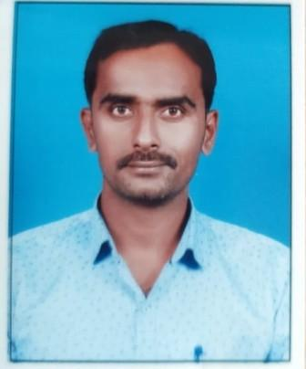

Name: Mr. N. A.Thorat
Fathers Name: Ashokrao
Department: Computer Science & engineering
Date of Joining: 1 Feb 2022 Designation: Assistant Professor
Phone No. 9096817011 Email ID: nathorat.cse@dacoe.ac.in
Permanent Address: A/P: Kalavade
Taluka: Karad Dist.: Karad State: Maharashtra
Local Address: A/P: Kalavade
Taluka: Karad Dist.: Karad State: Maharashtra
Marital Status: - Married Blood Group: A+
Date of Birth: 22/06/2022 Place of Birth: Karad
- Educational Qualification:
Degree | University/Board | Percentage | Class Obtained | Year of Passing
PhD
ME / M. Tech | JNTU ,Hyderabad | 77.79 | Distinction | 2014
BE / B. Tech | Sivaji University Kolhapur | 63.67 | First | 2009
12th | Kolhapur | 63.17 | First | 2005
10th | Kolhapur | 71.73 | First | 2003

- Experience (Years):
Teaching | 10.5 | Industrial |  | Others |  | Total | 10.5

- Paper/ Books Published:
Details | National | International | State | SCI/  Scopus Indexed | UGC  Approved
Journals |  | 2
Conferences

- FDP/STTP/Seminars/Workshop organized/Attended:
Details | Organised | Attended
FDP/STTP | - | 4
Seminar | -
Workshop | - | 5
Technical Event | -
Others | -

