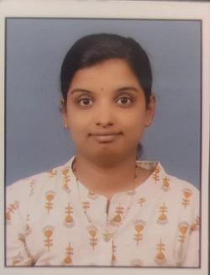
Name: Ms. Akshata Sunil Jadhav
Fathers/Husbands Name: Mr. Sunil Namdev Jadhav
Department: Computer Science & Engineering
Date of Joining: 01/08/2022 Designation: Assistant Professor
Phone No: 928414143012 Email ID:akshatasjadhav1996@gmail.com
Permanent Address: 182 Shaniwar Peth Mulik Chowk Karad
Taluka: Karad Dist.: Satara State: Maharashtra
Local Address: 182 Shaniwar Peth Mulik Chowk Karad
Marital Status: - Married Blood Group: AB+
Date of Birth: 07/09/1996 Place of Birth: Thane
Educational Qualification:
Degree | University/Board | Percentage | Class Obtained | Year of Passing
ME / M. Tech | PAH Solapur University | CGPA-9.34 | A | 2020
BE / B. Tech | Solapur University | 66.38 | A | 2018
Diploma | MSBTE | 64.80 | - | 2012
Experience (Years):
Teaching | 1.5 | Industrial | No | Others |  | Total | 1.5
Paper/ Books Published:
Details | National | International | State | SCI/  Scopus Indexed | UGC  Approved
Journals | 1 |  |  |  | 1
Conferences | 1

FDP/STTP/Seminars/Workshop organized/Attended:
Details | Organised | Attended
FDP/STTP |  | 1
Seminar
Workshop
Technical Event
Others

